FinallyClause

//finally is used for final cleanup

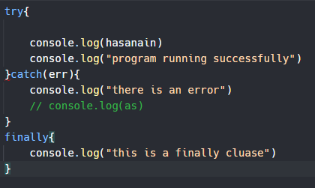

It will run at all cost wether the try has anerror or even if the error block has an error the script won’t crassh and thecode will keep runnin

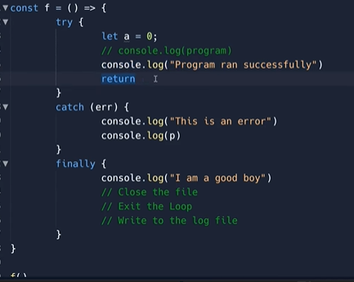

Jo harr hal mein run krna he krna hai usse hum finally mein daltay hai

Iss case mein return use kia hai humne function mein lkinis ke bawajood finally run hoga he hoga harrhal meon

## Refrence code

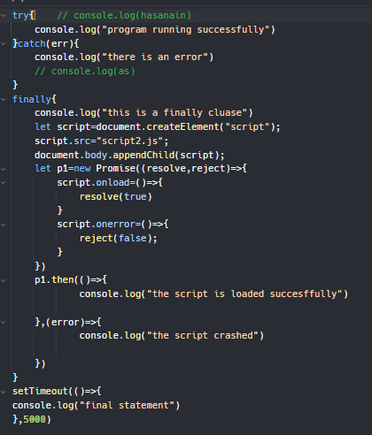

<https://replit.com/@Hasnain150/FinallyClause>

<https://www.youtube.com/watch?v=rWCGC2NWjcc&ab_channel=CodeWithHarry>